AZ – 204
Virutal Machines
- VM gets deployed to Virtual Network
- Virtual Network consist of one or more subnets
- When you create a VM , the wizard will give an option to create the Virtual Network

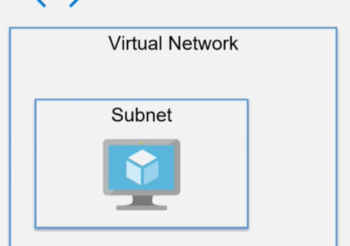

The Virtual Machine gets assigned a Network Interface
The Network interface gets assigned a private IP address
You can also allocate a Public IP Address
The Public IP address allows once to connect to the Virtual Machine from the internet

The VM can have multiple Disks
These are VHD files
By default get an OS disk assigned to the machine
You can assign Data disks to the machine as well

You can stop the VM whenever you don’t want the VM to run
You can control the traffic flow using Network Security Groups
You can also monitor the different underlying metrics – CPU utilization , Network Utilization

Deploying a VM

Subscription , RG ,Name , Region , Availability , Image , AZ Spot instance , Size , Username , Password , inbound port rules ( HTTP 80, HTTPS 443 , SSH 22 , RDP 3389 ) , Disk (attach new additional data disk) , Virtual Network , Subnet ,
Public IP Address , Boot diagnostic (storage account) , Tags

We can add additional disks also while creating

Deploying a Solution

Install the Web Deploy tool on the virtual machine
Assign a DNS name for the virtual machine
Add a Network Security Group rule on the network interface attached to the virtual machine

VM DNS name Configure IP address static , give DNS name
Publish to VM from VS directly

Management service (in VM) runs on port 8172

Add rule in VM for 8172 TCP

Installing Internet Information Services

To access the site from outside you need to add inbound security rule in Networking

Lab - ARM Templates

This is a JSON template that contains the resources that you want to create in Azure.
You can submit this template to Azure Resource Manager
Azure Resource Manager will then create the resources based on the template definition

The different elements of the template

$schema – this describes the version of the template language
contentVersion – this the version of the template
resources – this is the main section where you define the resources that need to be deployed as part of the template
parameters – these are values that can be provided to the template that can be used to customize the deployment of the resources.
Variables – these are values that can be reused in the template
Functions – these are user-defined functions that can be used in the template
Outputs – these are values that are returned after the deployment

We can export the template from the resources
We can use template deployment from Azure Portal - deploy using custom templates – from the UI build your own template , it also has some git hub templates , we can build our own template using the editor

We can reuse ARM the template multiple times

Deploying Docker on a Linux Virtual Machine

A Container is a standardized unit of software that allows developers to isolate their application from its underlying environment.

Azure Container Registry

This is a managed private Docker registry service
This service can be used to store private Docker container images
You can also integrate this service with the Azure Kubernetes service

Azure container instances

This service allows you to deploy isolated containers
Here you don’t need to provision virtual machines for the containers
You can have your containers running within a matter of seconds
Here the container instances get an IP address and a fully qualified domain name

Network Security Groups

Network security groups are used to filter network traffic to and from Azure resources in an Azure virtual network
It consists of rules that can be used to allow or deny inbound and outbound traffic

Name , Priority (Rules are processed in priority order with lower numbers processed first) , Source or destination , Protocol , Direction (inbound or outbound rule) ,Port range , Action – Allow or deny

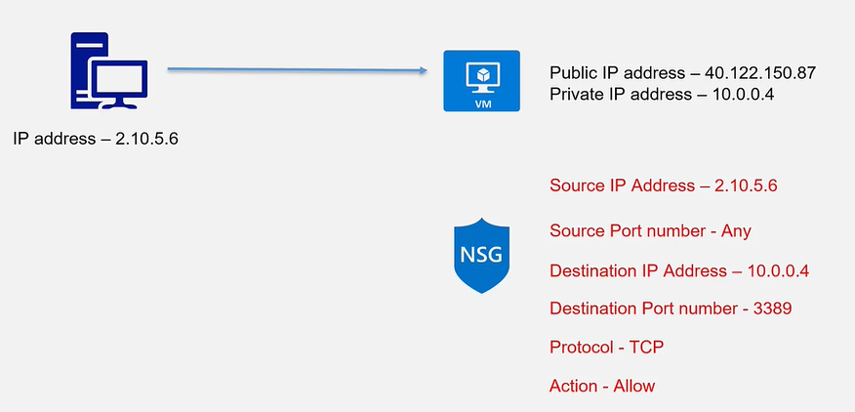

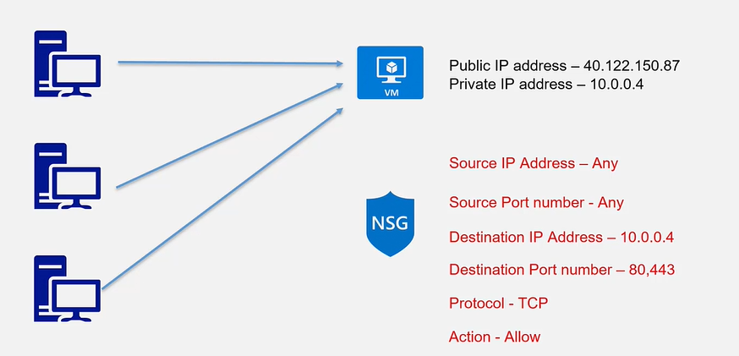

Rules in Networking under the VM

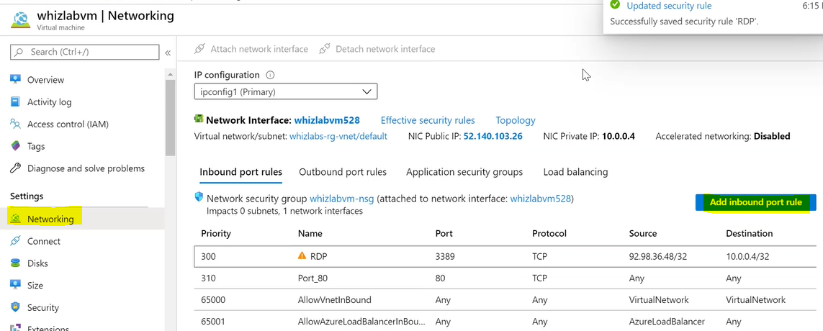

Azure Bastion Service

This is a fully managed platform as a service which is provisioned inside of the virtual network itself
It helps provide secure RDP/SSH connectivity to virtual machines directly in Azure portal over SSL
Here the virtual machines don’t need to be assigned public IP address for virtual machine connectivity
This alleviates the need to manage Network Security groups

Azure Web App Service

Platform as a service on the cloud
Service for hosting web applications
Used to remove the burden of managing the underlying infrastructure for web applications

We just need to deploy the application

.Net,Java,Ruby,Node.js,PHP,Python
The underlying servers can be windows or linux

DevOps , Blue Green Deployments , Authenticate with external providers

Azure App Service Plan

Dev/Test , Production , Isolated

az appservice plan create –name plan1 –resource-group whizlabs-rg –sku B1
az webapp create –name whizlapapp900 –plan plan1 –resource-group whizlabs -rg

Web App Settings

Using custom domains
Using the backup and restore feature
Other features available in Azure Web Apps

For custom domain App Service Plan must be Shared,Basic,Standard or Premium

Backup the App configuration , File content and the database connected to the application to an Azure storage account
To use the Backup and Restore feature , the underlying App Service Plan needs to be in the Standard or Premium tier.
Limit in the size of the backups of application and database is 10GB

Settings
Vnet Integration
Hybrid connections
Azure Front Door with Web Application Firewall
Azure CDN

Azure App Service Logs

You have different types of logs available for your Azure Web Apps
Application logging - These are log messages generated by application code
Each of these message are generally assigned one of the following categories – Critical , Error , Warning , Info , Debug and Trace
Web server logging – These are all the RAW HTTP request data
Details Error Messages – These are copies of the .htm error pages that would have been sent to the client browser
Failed request tracing – This is detailed tracing information on failed requests ,which includes a trace of the IIS components
Deployment logging – These are logs when content is published to an application

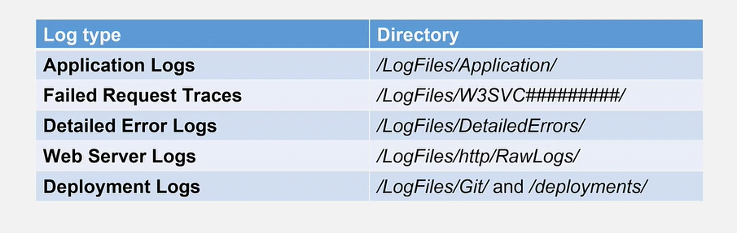

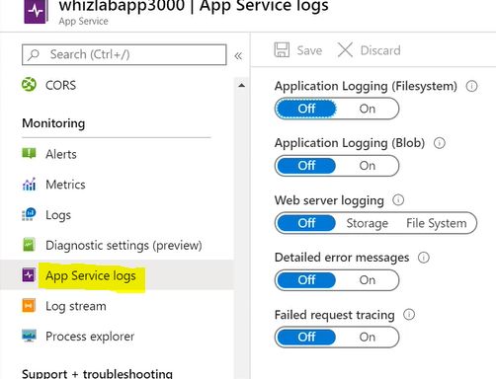

Web App Settings Connection string for connecting to the Database

